Branch: MCA (Data Science) | Semester: 2
Student Name: Adarsh Mishra | UID: 25MCD10065
Subject Name: Technical Training - I | Subject Code: 25CAP-652
Section/Group: 25MCD – 1(A) | Date of Performance: 13 January,2026

Experiment No. : 1

- Aim/Overview of the practical:
To design and implement a sample database system using DDL, DML, and DCL commands, including database creation, data manipulation, schema modification, and role-based access control to ensure data integrity and secure, read-only access for authorized users.

- Objective:
To gain practical experience in implementing Data Definition Language (DDL), Data Manipulation Language (DML), and Data Control Language (DCL) operations in a real database environment. This will also include implementing role-based privileges to secure data.

- Software Used:
- PostgreSQL
- pgAdmin4

- Code for experiment/Practical:

CREATE TABLE Department (
Dept_ID INT PRIMARY KEY,
Dept_Name VARCHAR(50) UNIQUE NOT NULL,
Location VARCHAR(50) NOT NULL
);

CREATE TABLE Employee (
Emp_ID INT PRIMARY KEY,
Emp_Name VARCHAR(50) NOT NULL,
Salary INT CHECK (Salary > 0),
Dept_ID INT REFERENCES Department(Dept_ID),
Email VARCHAR(100) UNIQUE
);

CREATE TABLE Project (
Project_ID INT PRIMARY KEY,
Project_Name VARCHAR(50) NOT NULL,
Budget INT CHECK (Budget >= 10000),
Dept_ID INT REFERENCES Department(Dept_ID)

);

INSERT INTO Department VALUES
(1, 'HR', 'Mumbai'),
(2, 'IT', 'Pune'),
(3, 'Finance', 'Delhi');

INSERT INTO Employee VALUES
(101, 'Akash', 50000, 2, 'akash@org.in'),
(102, 'Boby', 45000, 1, 'boby@org.in'),
(103, 'Chetan', 60000, 2, 'chetan@org.in');

INSERT INTO Project VALUES
(201, 'Payroll System', 200000, 1),
(202, 'Web Application', 500000, 2);

SELECT * FROM Department;
SELECT * FROM Employee;
SELECT * FROM Project;

UPDATE Employee
SET Salary = 55000
WHERE Emp_ID = 101;

DELETE FROM Department
WHERE Dept_ID = 3;

CREATE ROLE Analyst
LOGIN PASSWORD 'analyst123'

GRANT SELECT ON Department TO Analyst;
GRANT SELECT ON Employee TO Analyst;
GRANT SELECT ON Project TO Analyst;

REVOKE CREATE ON DATABASE DB1 FROM analyst;

ALTER TABLE Employee
ADD Phone_No INT(10);

ALTER TABLE Employee
ALTER COLUMN Emp_Name TYPE VARCHAR(50);

DROP TABLE Project;

- Result/Output/Writing Summary:
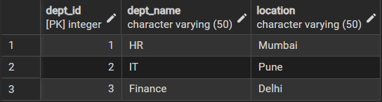
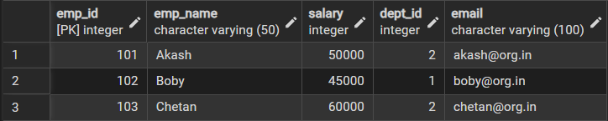
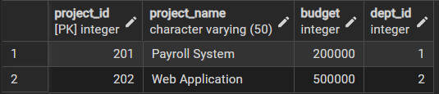

After Update Query, Employee:
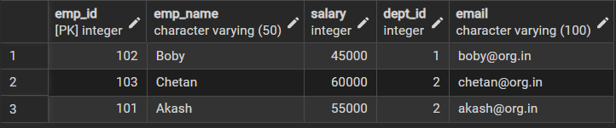

After Delete Query, Department:

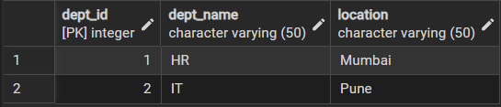

After Alter Query, Employee:
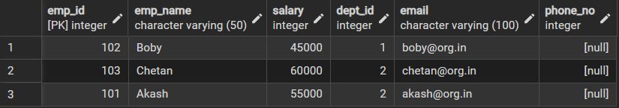

After Drop Table Query, Project:
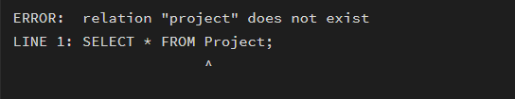

6. I/O Analysis (Input / Output)
Input:
• Department, Employee, and Project table creation queries
• Records inserted into all tables using INSERT commands
• Update query to modify employee department
• Delete queries to remove project and employee records
• Role creation and privilege assignment queries
• ALTER and DROP table commands

Output:
• Department, Employee, and Project tables created successfully
• Records inserted, updated, and deleted correctly
• Referential integrity maintained between tables
• Data displayed correctly using SELECT queries
• Role-based access verified using GRANT and REVOKE
• Table structure modified and project table dropped successfully

Learning outcomes (What I have learnt):

- Understand how to design a relational database using multiple tables with proper relationships.
- Learn to apply constraints to maintain data integrity and consistency.
- Perform basic data manipulation operations such as INSERT, UPDATE, and DELETE.
- Implement database security by managing users, roles, and access privileges.

